HALF ADDER
OBJECTIVE:
- To observe the working of half adder
THEORY:

Half adder: A half adder is a logical circuit that performs an addition operation on two binary digits. The half adder produces a sum and a carry value which are both binary digits. The drawback of this circuit is that in case of a multi bit addition, it cannot cater to carry.
EQUATION FOR HALF ADDER:

EQUIPMENT / REQUIREMENT:
- IC 7486
- 7408 IC.
- 7432 IC.
- Breadboard
- LED
- 0-5 VOLT DC Power Supply.

PROCEDURE:
Construct the combinational circuit as diagram given figure 6.1 after constructing both of these circuits, observe the output and complete the truth table.
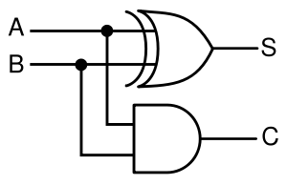
Figure 7.1 half adder circuit

OBSERVATION TABLE:

A | B | C | S
0 | 0
0 | 1
1 | 0
1 | 1
Table 7.1

CONCLUSION:

